### Software Quality Assurance and Testing Technology Mini project



**System Test Plan**

**For**

***Renju Game System***

***（五子棋）***

Written by: 袁绍潭 19301162

Date: 2022.05.29

|  |  |
| --- | --- |
| 袁绍潭 19301162 | 2020.05.29 |
| Renju Game System Test Plan |
| Version 1.0 |

**Table of Contents**

1. Introduction 2
   1. Purpose 2
   2. Objectives 2
2. Functional Scope 3

3. 5



Overall Strategy and Approach

* 1. Testing Strategy
  2. System Testing Entrance Criteria
  3. Testing Types
  4. Suspension Criteria and Resumption Requirements
  5. Test Data

Execution Plan

4.1 Execution Plan

Defect Reporting

* 1. Defect Tracking
  2. Defect Reporting and Reports
  3. Defect Management Process
  4. Defect Severity Definitions

Environment

6.1 Environment Test Schedule Assumptions

Risks and Contingencies Appendices

5

5

5

6

6

4. 9

9

5. 39

39

39

39

39

6. 41

41

7. 41

8. 41

9. 41

10. 42

# Introduction

* 1. **Purpose**

This document is a test plan for Renju Game System Testing, produced by the System Testing team.

It describes the testing strategy and approach to testing the team will use to verify that the application meets the established requirements of the business prior to release.

* 1. **Objectives**

### Meets the requirements, specifications and the Business rules.

The specification of this test submission document is:

* + - 1. Management document, document status: completed and approved. Document number shall be indicated. The document contains the following types: plan, summary, report, meeting minutes, memos, applications, etc. All documents must be stored in the repository and the corresponding VSS library. The documents put into the knowledge base shall be put into the Department Assistant uniformly, and the documents must be approved and approved.
      2. Technical documents, document status: completed, approved and approved. Document number shall be indicated. The documents include the following types: design documents, requirements documents, test design documents, interface prototype software, user manual, installation manual, technical white paper, source code, software products, etc. All documents must be stored in the repository and the corresponding VSS library. The documents put into the knowledge base shall be put into the Department Assistant uniformly, and the documents must be approved and approved.

### Supports the intended business functions and achieves the required software standards.

The expected business function of this test is to realize the Renju game system, which should realize local battle, winning judgment, game Storage, game replay, game reload, score ranking and music playing. All functional and non functional requirements in the product specification should be realized.

### Satisfies the Entrance Criteria for User Acceptance Testing.

* 1) Functional requirements must be available.
* 2) Application code should be fully developed.
* 3) Unit test, integration test and system test should be completed.
* 4) There are no obstacles, high or medium defects in the system integration testing phase.
* 5) Regression test should be completed without major defects.
* 6) The traceability matrix of all tests shall be completed.

# Functional Scope

The Modules in the scope of testing for the Renju System Testing are mentioned in the document attached in the following path :

## Local Battle Model

### Start New Game

User can click “双人对战” button to create new game. If there is a unfinished game stored in the game, the system will ask user whether continue the game.

### Place Chess Pieces

During the game, two players can place pieces one by one, and the color of the pieces will black and white alternate. Click the chessboard, the pieces will place on correct place. The system do not use Internet, so two players should use one computer and mouse to play it.

### Winning Judgment

Every time user places a piece on the board, system will judge whether the game is done.

Winning of Renju game is that:

*Black plays first, and players alternate in placing a stone of their color on an empty intersection.*

*The winner is the first player to get an unbroken row of five stones horizontally, vertically, or diagonally.*

So, the system will check pieces around the piece placed just now and judge whether the game is done.

* 1. **Game Storage Model**

### Store unfinished Game（储存残局）

During the game, if players want to pause the game and continue in the next time, they can store the game in the system, and continue whenever they want.

But if they start a new game, the storage will be canceled.

### Store finished Game

When the game finished, players can choose to store the game in the system. If the finished game is shored in the system, the score of this game will upload to ranking list, and players can watch playback of this game.

* 1. **Game loading Model**

### Load unfinished game

If there is an unfinished game stored in the system, and players want to continue, the system will load the chessboard information form file and display game page. Players can continue the game soon.

### Finished game playback(回放)

If there are some finished game stored in the system, players can click”排行榜”button to check all the games. If players want to watch the playback of a game, they can click the game on the ranking list and system will display the playback.

* 1. **Music Management Model**

In the system, there are some button controlling background music. Players can open, pause and

close the music whenever they want.



1. **Overall Strategy and Approach**
   1. **Testing Strategy**

Renju Game System Testing will include testing of all functionalities that are in scope (Refer Functional Scope Section) identified. System testing activities will include the testing of new functionalities, modified functionalities, screen level validations, work flows, functionality access, testing of internal & external interfaces.

* 1. **System Testing Entrance Criteria**

In order to start system testing, certain requirement must be met for testing readiness. The readiness can be classified into:

1. The developer has finished coding and completed the unit test.
2. The functions specified in the requirements specification or submitted by developers have been realized.
3. The basic flow of the system under test can go through, and the functions on the interface are realized, which are in line with the functions specified in the design documents.
4. The test scope is consistent with the function of the requirement specification. If not, the requirement specification shall be updated and the change application form shall be provided.
5. The requirements document is approved and the review document is submitted.
   1. **Testing Types**

|  |  |
| --- | --- |
| **Testing Type** | **Test Content** |
| Black-Box Test | Test samples with various critical points and capabilities are selected to test, and each test sample represents a category |
| White-Box Test | Ensure that all kinds of test samples are covered and the test scope is comprehensive |
| Unit Test | The person in charge of each module uses JUnit for unit test |
| Integration Test | All the modules are merged one by one and tested to ensure the normal use of the functional interfaces |
| System Test | The overall test of the system to ensure that the work is normal, performance standards |

### Usability Testing

User interface attributes, cosmetic presentation and content will be tested for accuracy and general usability. The goal of Usability Testing is to ensure that the User Interface is comfortable to use and provides the user with consistent and appropriate access and navigation through the functions of the application (e.g., access keys, consistent tab order, readable fonts etc.)

### Functional Testing

The objective of this test is to ensure that each element of the component meets the functional requirements of the business as outlined in the:

1. Business / Functional Requirements
2. Business rules or conditions
3. Other functional documents produced during the course of the project i.e. resolution to issues/change requests/feedback
   1. **Suspension Criteria and Resumption Requirements**

This section will specify the criteria that will be used to suspend all or a portion of the testing activities on the items associated with this test plan.

### Suspension Criteria

Testing will be suspended if the incidents found will not allow further testing of the system/application under-test. If testing is halted, and changes are made to the hardware, software or database, it is up to the Testing Manager to determine whether the test plan will be re-executed or part of the plan will be re-executed.

* One third of the test cases cannot be executed;
* When the test achieves the milestone target (such as unit test), it needs to be adjusted;
* Accidental damage of hardware or objective environment;
* The test practice cannot meet the test plan;

### Resumption Requirements

Resumption of testing will be possible when the functionality that caused the suspension of testing has been retested successfully.

* Debug and optimize the module that causes pause, and recover after passing the test;
* When the milestone is completed, the manager summarizes and arranges to enter the next stage;
* The manager quickly coordinates and solves the influence of objective factors, and recovers when ready;
* Change and optimize the test plan, and resume the test according to the new plan.
  1. **Test Data**

Test data requirements are drawn up based on the functional requirements that are due for testing. The testing team will identify test cases that can be grouped into test scenarios and detail the data required to complete the testing activities.

### Game Start and Enter Name Module

|  |  |
| --- | --- |
|  | **Test Module 1: Game Start and Enter Name Module** |
| **Test Purpose:**  Check that whether user can start a new game, and whether system can store, display names entered by users. Verify whether system can realize invalid names.  **Test Point 1:** Whether the user can start new game.  **Test Point 2:** Whether the user can start new game when there is an unfinished game stored in the system.  **Test Point 3:** Whether system can identify invalid input names. | |
| **Test Condition:**  Describe the corresponding data clearly, including general value, boundary value and abnormal value. | |
| **Test Tools:**  IntelliJ IDEA 2021.1.1 x64 Visual Studio 2019 Renju.exe | |

|  |
| --- |
| **Test Process:**  First of all, we need to click “双人对战” button on the menu, check whether the system can turn to game page. If there is an unfinished game stored in the system, when we click the button, system should show a dialog which ask user whether create new game or continue last game. If user choose to create new game, the system should turn to game page.  Second, after turning to game page, user should enter two players names one by one. Test the null value, input error and input correct three cases. |
| **Test Expectation:**  User can create new game whenever they want, the system can turn to game page. When user input their name, in the case of wrong operation, the corresponding feedback cannot be obtained and there will be corresponding prompt. |

|  |
| --- |
| **Test Module 2: Winning Judgment Module** |
| **Test Purpose:**  Check that whether system can identify the game is over when there are 5 some color pieces in a line. Every condition should be checked in.  **Test Point 1:** An unbroken row of five stones horizontally.  **Test Point 2:** An unbroken row of five stones vertically.  **Test Point 3:** An unbroken row of five stones diagonally.  **Test Point 4:** An unbroken row of five stones near the boundary(在棋盘边界处的判定). (因为整个棋盘都下满还没决出胜负的情况不好实现，所以不进行考虑) |
| **Test Condition:**  Describe the corresponding data clearly, including general value, boundary value and abnormal value. |
| **Test Tools:**  IntelliJ IDEA 2021.1.1 x64 Visual Studio 2019 Renju.exe |
| **Test Process:**  In this test module, we should create every condition that game should be over: An unbroken row of five stones horizontally, vertically or diagonally. We can use three test case to check it.  Finally, we use one test case to test whether the judgment near the chessboard boundary is valid. |
| **Test Expectation:**  System can identify the finish of the game and display which player is winning. |

### 3.5.3 Game Storage and reloading Module



**3.5.2 Winning Judgment Module**

|  |
| --- |
| **Test Module 3: Game Storage and reloading Module** |
| **Test Purpose:**  Check that whether system can store the unfinished when user wants to leave and store the game. When user |

|  |
| --- |
| wants to continue the game, system should reload the game from the file.  Check that whether system can store the finished when a game is over. The game can be queried in ranking list and show playback when user click on it.  **Test Point 1:** Whether the system can store unfinished game.  **Test Point 2:** Whether the system can reload unfinished game from file.  **Test Point 3:** Whether the system can store finished game in the rank file.  **Test Point 4:** Whether the system can reload and show playback of any finished game. |
| **Test Condition:**  Describe the corresponding data clearly, including general value, boundary value and abnormal value. |
| **Test Tools:**  IntelliJ IDEA 2021.1.1 x64 Visual Studio 2019 Renju.exe |
| **Test Process:**  In this test module, for unfinished game, use three test case to check storage and loading. One is to store the game when the game is unfinished. The other one is to cancel store the game when we click “返回主菜单” button. The last one is to cancel continue game when we click “双人对战” button.  For unfinished game, use two test case to check storage and loading. One is to store the game when the game is over, check the ranking list and playback. The other one is to cancel store the game. |
| **Test Expectation:**  System can store and reload the information of unfinished and finished games. |



1. **Execution Plan**
   1. **Execution Plan**

### Black-Box Test

In the black box test, various critical points and special characters are selected to ensure that the categories under various circumstances are covered by the test samples.

### White-Box Test

In the white box test, read through the source code of the project, clarify the code relationship, draw the logical structure, optimize the project and find out the potential dangers.

Test every possible definition execution process of every variable to find out potential errors and correct them.

### Unit Test

Unit test is performed on the back end of each function: start new game, place chess pieces, winning judgment, game storage, game reloading, game playback, music controlling and other function blocks. JUnit is used for unit test to ensure the smooth and normal implementation of each module.

### Integration Test

The main function or goal of integration testing is the interface between test units or modules. In the unit test, each module is tested. In the integration test, each module is assembled one by one until all modules are integrated together, and whether the combination is implemented correctly is checked.

Game start and enter name module, winning judgment module and game storage & reloading module should be tested one by one, including interface and UI test.

### System Test

System test of the Renju Game system to detect the stability of the system. Because the project does not need Internet and server, we do not need stress test for system.

* 1. **Test Cases**

### Game Start and Enter Name Test Case

4.2.1.1 Start_Name_001

|  |  |  |  |  |  |  |  |  |  |
| --- | --- | --- | --- | --- | --- | --- | --- | --- | --- |
| **Test Scenario ID** | | Start_Name | | | | **Test Case ID** | | Start_Name_001 | |
| **Test Case Description** | | User click “双人对战” button and enter two right names. | | | | **Test Priority** | | High | |
| **Pre-Requisite** | | There is no unfinished game stored in the system. | | | | **Post Requisite** | | Come back to main menu page. Don’t save game. | |
| Test Execution Steps | | | | | | | | | |
| **S.NO** | **Action** | | **Inputs** | **Expected Output** | **Actual Output** | | **Test result** | | **Test Comments** |
| 1 | Launch “五 | | Null | System start, main | System starts, | | Pass | | [Beijing 06/08/2022 |

|  |  |  |  |  |  |  |
| --- | --- | --- | --- | --- | --- | --- |
|  | 子棋.exe” |  | menu page. | main menu page. |  | 10:37 AM]:  Launch successful |
| 2 | Click “双人对战” button | Null | Game page, display name input dialog. | Game page, display name input dialog. | Pass | [Beijing 06/08/2022 10:40 AM]:  Page changing successful |
| 3 | Enter two valid names, and submit. | Jack John | submit successful, users can place pieces on the chessboard. | submit successful, users can place pieces on the chessboard. | Pass | [Beijing 06/08/2022 10:45 AM]:  Game start successful |

Click “双人对战” button

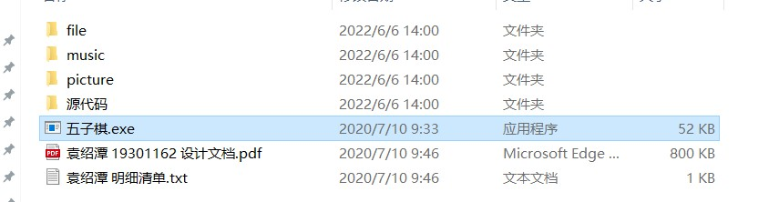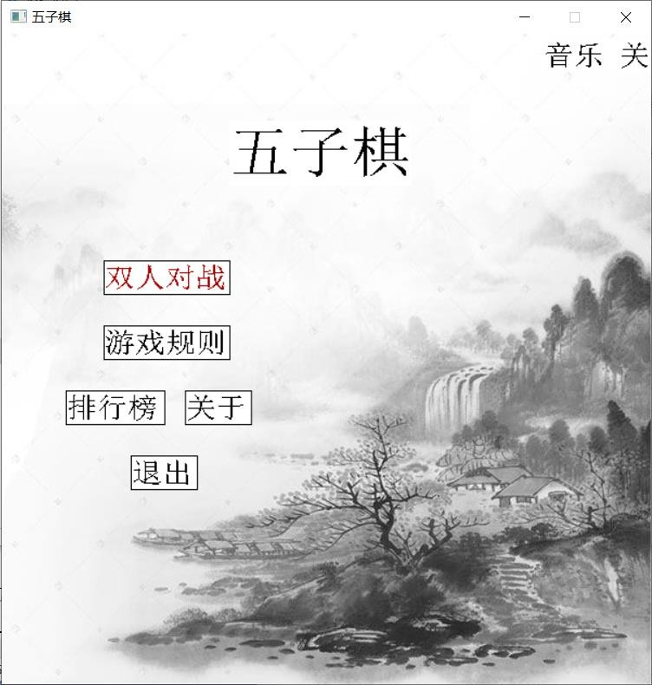

Launch system

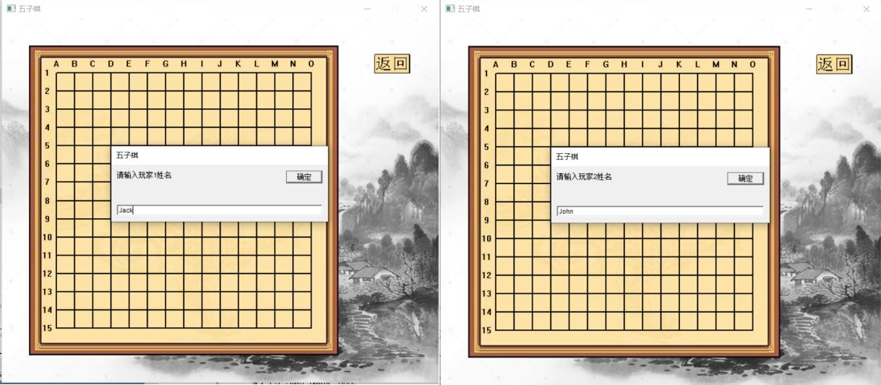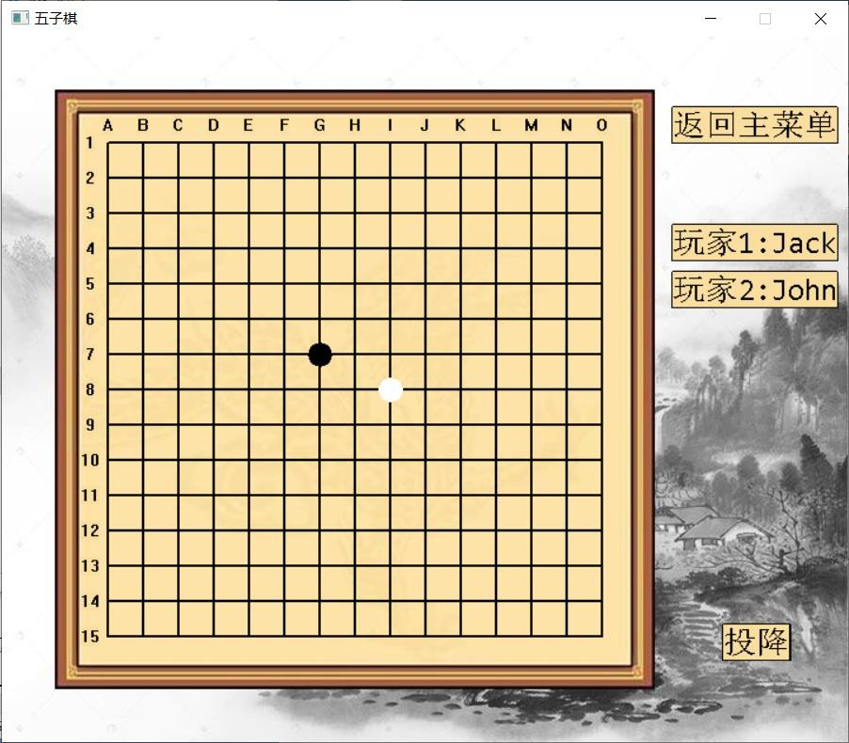

Input two names

Game start sucessful

4.2.1.2 Start_Name_002

|  |  |  |  |  |  |  |  |  |  |
| --- | --- | --- | --- | --- | --- | --- | --- | --- | --- |
| **Test Scenario ID** | | Start_Name | | | | **Test Case ID** | | Start_Name_002 | |
| **Test Case Description** | | User click “双人对战” button and enter null name in the dialog. | | | | **Test Priority** | | High | |
| **Pre-Requisite** | | There is no unfinished game stored in the system. | | | | **Post Requisite** | | Come back to main menu page. | |
| Test Execution Steps | | | | | | | | | |
| **S.NO** | **Action** | | **Inputs** | **Expected Output** | **Actual Output** | | **Test result** | | **Test Comments** |

|  |  |  |  |  |  |  |
| --- | --- | --- | --- | --- | --- | --- |
| 1 | Launch “五子棋.exe” | Null | System start, main menu page. | System starts, main menu page. | Pass | [Beijing 06/08/2022 11:00 AM]:  Launch successful |
| 2 | Click “双人对战” button | Null | Game page, display name input dialog. | Game page, display name input dialog. | Pass | [Beijing 06/08/2022 11:05 AM]:  Page changing successful |
| 3 | Enter nothing in the dialog, and submit. | Null | submit fail,  system show “名字不能为空” | submit fail,  system show “名字不能为空” | Pass | [Beijing 06/08/2022 11:10 AM]:  Invalid attempt stopped |



Main menu, Click “双人对战” button

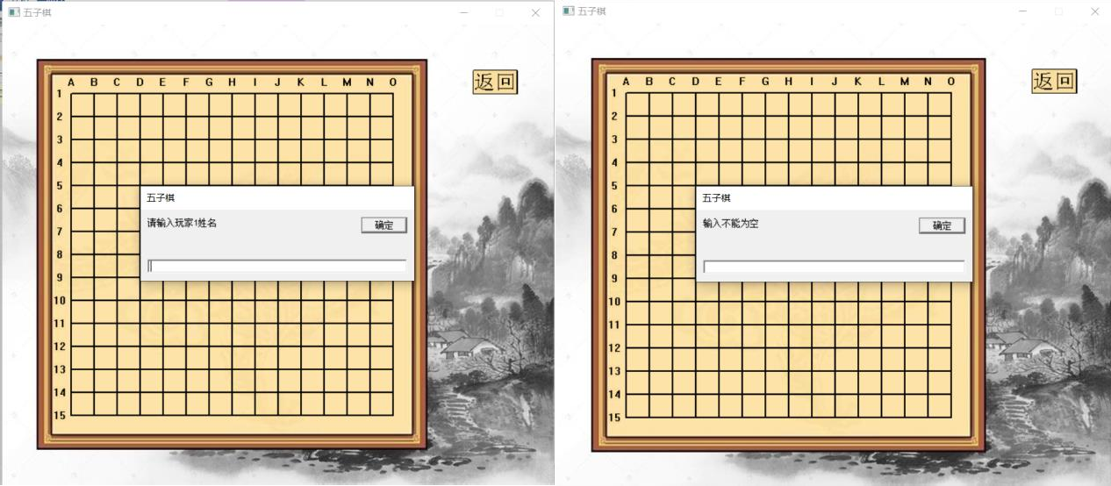

Enter nothing and submit

4.2.1.3 Start_Name_003

|  |  |  |  |  |  |  |  |  |  |
| --- | --- | --- | --- | --- | --- | --- | --- | --- | --- |
| **Test Scenario ID** | | Start_Name | | | | **Test Case ID** | | Start_Name_003 | |
| **Test Case Description** | | User click “双人对战” button and enter invalid name in the dialog.(包括特殊字符) | | | | **Test Priority** | | High | |
| **Pre-Requisite** | | There is no unfinished game stored in the system. | | | | **Post Requisite** | | Come back to main menu page. | |
| Test Execution Steps | | | | | | | | | |
| **S.NO** | **Action** | | **Inputs** | **Expected Output** | **Actual Output** | | **Test result** | | **Test Comments** |
| 1 | Launch “五子棋.exe” | | Null | System start, main menu page. | System starts, main menu page. | | Pass | | [Beijing 06/08/2022 11:00 AM]:  Launch successful |
| 2 | Click “双人对战” button | | Null | Game page, display name input dialog. | Game page, display name input dialog. | | Pass | | [Beijing 06/08/2022 11:05 AM]:  Page changing successful |
| 3 | Enter invalid names, and submit. | | Wjd hfal(中间有空格)  H#(jd | submit successful names are displayed in the screen. | submit successful (特殊字符不影响后续功能，但是中间有空格会影  响存取功能) | | Not | | [Beijing 06/08/2022 11:10 AM]:  Invalid attempt stopped |

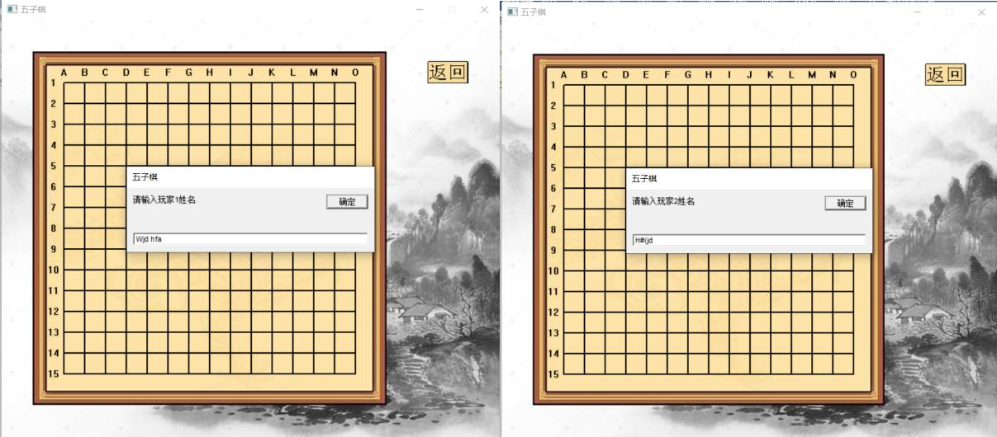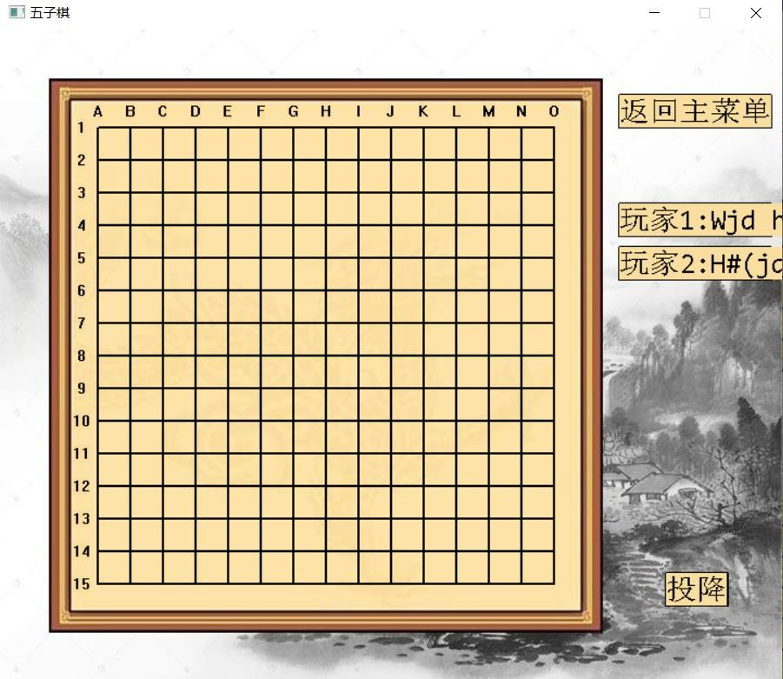

Input “Wjd hfal” and “H#(jd”

Submit successful and show names on the screen

* + 1. **Winning Judgment Test Case**
       1. Judge_Test_001

|  |  |  |  |  |  |  |  |  |  |
| --- | --- | --- | --- | --- | --- | --- | --- | --- | --- |
| **Test Scenario ID** | | Winning_Judge | | | | **Test Case ID** | | Judge_001 | |
| **Test Case Description** | | Verify whether system can identify an unbroken row of five stones horizontally. And finish the game. | | | | **Test Priority** | | High | |
| **Pre-Requisite** | | Start a new game. | | | | **Post Requisite** | | Come back to main menu page. Don’t save game. | |
| Test Execution Steps | | | | | | | | | |
| **S.NO** | **Action** | | **Inputs** | **Expected Output** | **Actual Output** | | **Test result** | | **Test Comments** |

|  |  |  |  |  |  |  |
| --- | --- | --- | --- | --- | --- | --- |
| 1 | Start new game. | Jack John | Start new game successful. | Start new game successful. | Pass | [Beijing 06/08/2022 14:00 AM]:  Launch successful |
| 2 | Place pieces that make unbroken row of four stones horizontally | Click crosses on the chessboard to place pieces | Pieces can be placed on the chessboard. | Pieces can be placed on the chessboard. | Pass | [Beijing 06/08/2022 14:05 AM]:  Placed successful |
| 3 | Place the last piece that make unbroken row of five stones horizontally | Click cross on the chessboard to place the piece | There are unbroken five stones horizontally. System show “黑棋/白旗获胜”.  And show a dialog ask whether to save  game. | There are unbroken five stones horizontally.  System show “黑棋/白旗获胜” and show the dialog. | Pass | [Beijing 06/08/2022 14:10 AM]:  Winning judgment successful |

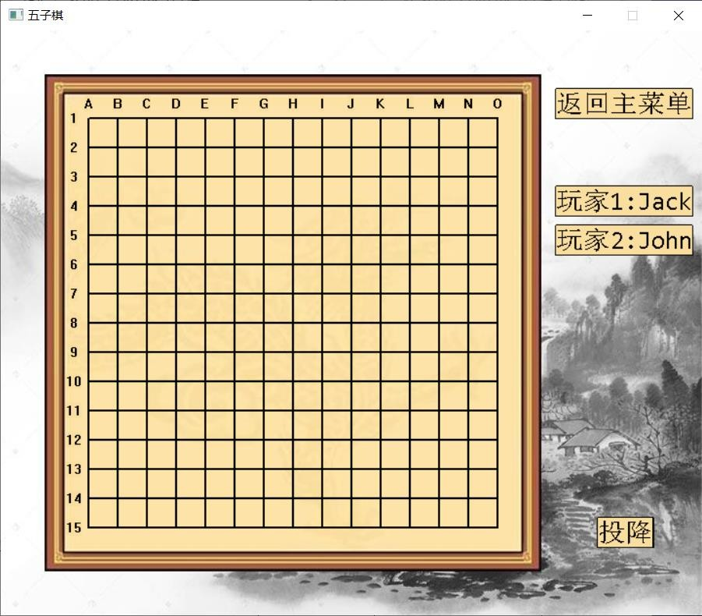

Start new game

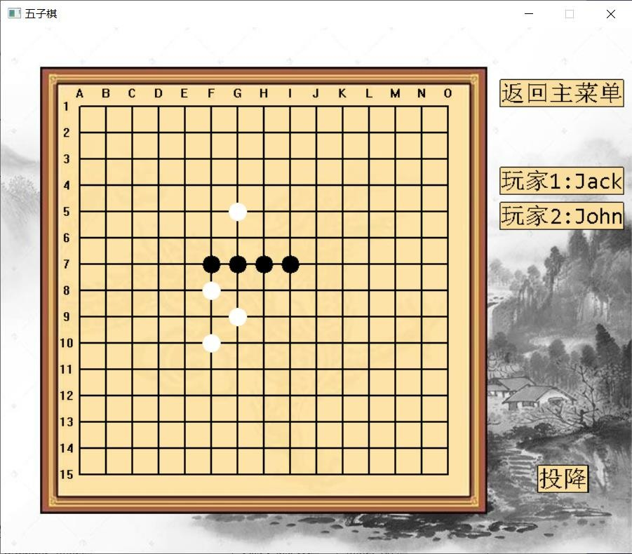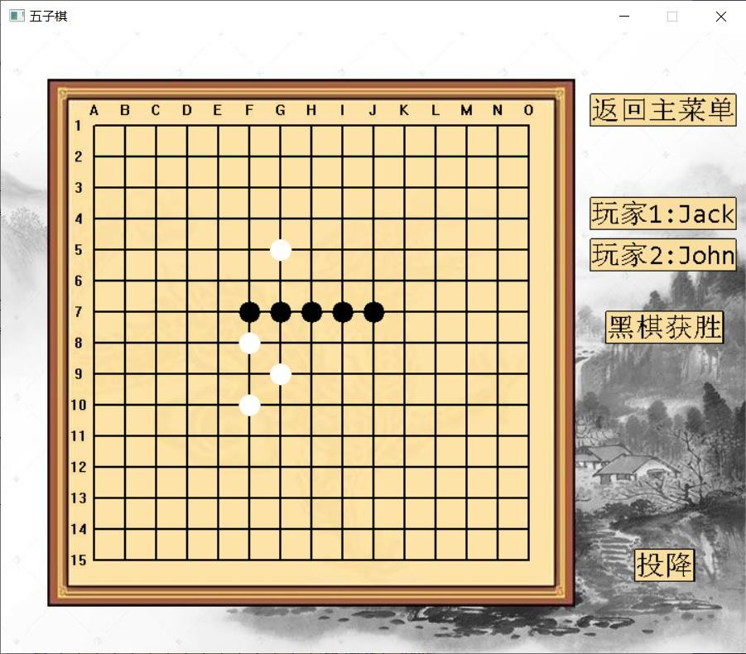

Make unbroken row of four stones horizontally

Unbroken five stones horizontally. Show “黑棋获胜”.

4.2.2.2 Judge_Test_002

|  |  |  |  |
| --- | --- | --- | --- |
| **Test Scenario ID** | Winning_Judge | **Test Case ID** | Judge_002 |
| **Test Case Description** | Verify whether system can identify an unbroken row of five stones vertically. And finish the game. | **Test Priority** | High |
| **Pre-Requisite** | Start a new game. | **Post Requisite** | Come back to main menu page. Don’t save game. |
| Test Execution Steps | | | |

|  |  |  |  |  |  |  |
| --- | --- | --- | --- | --- | --- | --- |
| **S.NO** | **Action** | **Inputs** | **Expected Output** | **Actual Output** | **Test result** | **Test Comments** |
| 1 | Start new game. | Jack John | Start new game successful. | Start new game successful. | Pass | [Beijing 06/08/2022 14:20 AM]:  Launch successful |
| 2 | Place pieces that make unbroken row of four stones vertically | Click crosses on the chessboard to place pieces | Pieces can be placed on the chessboard. | Pieces can be placed on the chessboard. | Pass | [Beijing 06/08/2022 14:25 AM]:  Placed successful |
| 3 | Place the last piece that make unbroken row of five stones vertically | Click cross on the chessboard to place the piece | There are unbroken five stones vertically. System show “黑棋/白旗获胜”.  And show a dialog ask whether to save  game. | There are unbroken five stones vertically. System show “黑棋/白旗获胜” and show the dialog. | Pass | [Beijing 06/08/2022 14:30 AM]:  Winning judgment successful |



Start new game

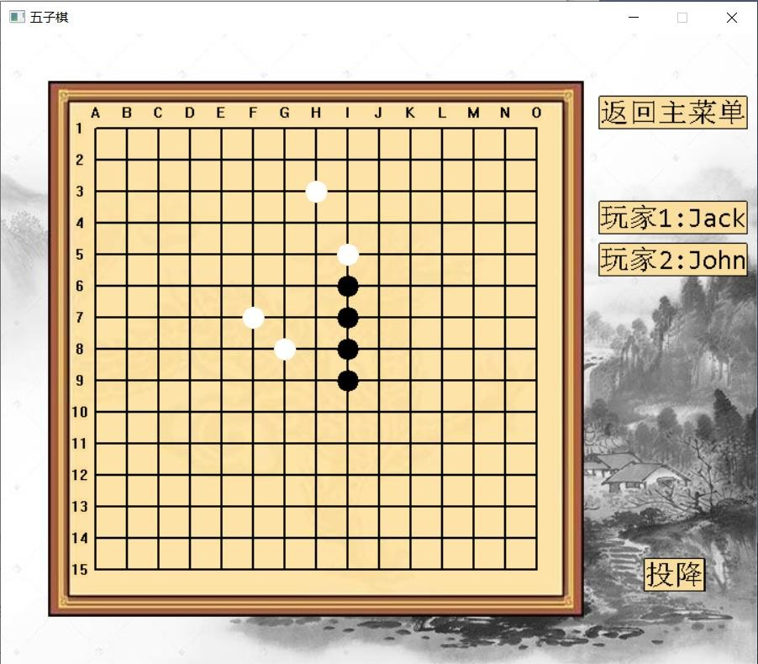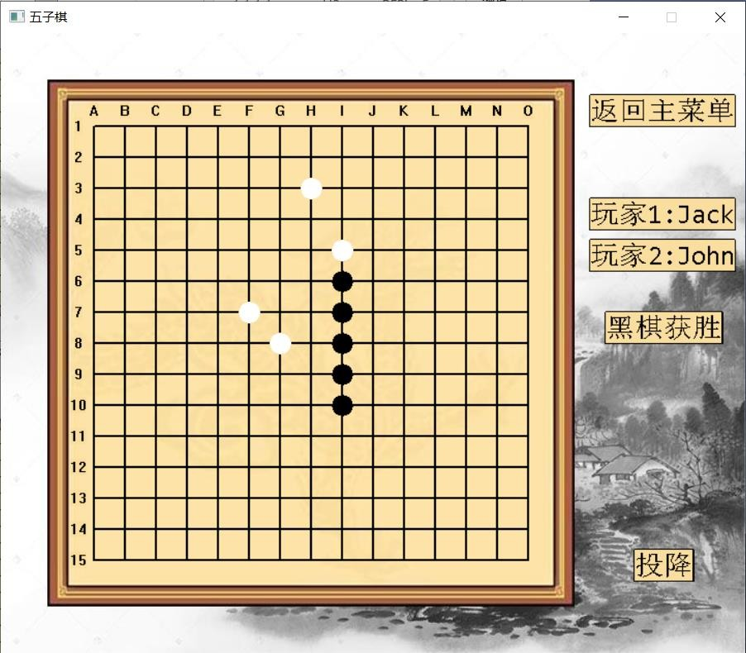

Make unbroken row of four stones vertically

Unbroken five stones vertically. Show “黑棋获胜”.

4.2.2.3 Judge_Test_003

|  |  |  |  |
| --- | --- | --- | --- |
| **Test Scenario ID** | Winning_Judge | **Test Case ID** | Judge_003 |
| **Test Case Description** | Verify whether system can identify an unbroken row of five stones bottom-left to top-right diagonally(左下到右上). And finish the game. | **Test Priority** | High |
| **Pre-Requisite** | Start a new game. | **Post Requisite** | Come back to main menu page. Don’t save game. |

|  |  |  |  |  |  |  |
| --- | --- | --- | --- | --- | --- | --- |
| Test Execution Steps | | | | | | |
| **S.NO** | **Action** | **Inputs** | **Expected Output** | **Actual Output** | **Test result** | **Test Comments** |
| 1 | Start new game. | Jack John | Start new game successful. | Start new game successful. | Pass | [Beijing 06/08/2022 14:40 AM]:  Launch successful |
| 2 | Place pieces that make unbroken row of four stones diagonally | Click crosses on the chessboard to place pieces | Pieces can be placed on the chessboard. | Pieces can be placed on the chessboard. | Pass | [Beijing 06/08/2022 14:45 AM]:  Placed successful |
| 3 | Place the last piece that make unbroken row of five stones bottom-left to top-right diagonally | Click cross on the chessboard to place the piece | There are unbroken five stones diagonally. System show “黑棋 获 胜 ”. And show a dialog ask whether to save game. | There are unbroken five stones diagonally. System show “黑棋 获 胜 ” and show the dialog. | Pass | [Beijing 06/08/2022 14:50 AM]:  Winning judgment successful |

Start new game

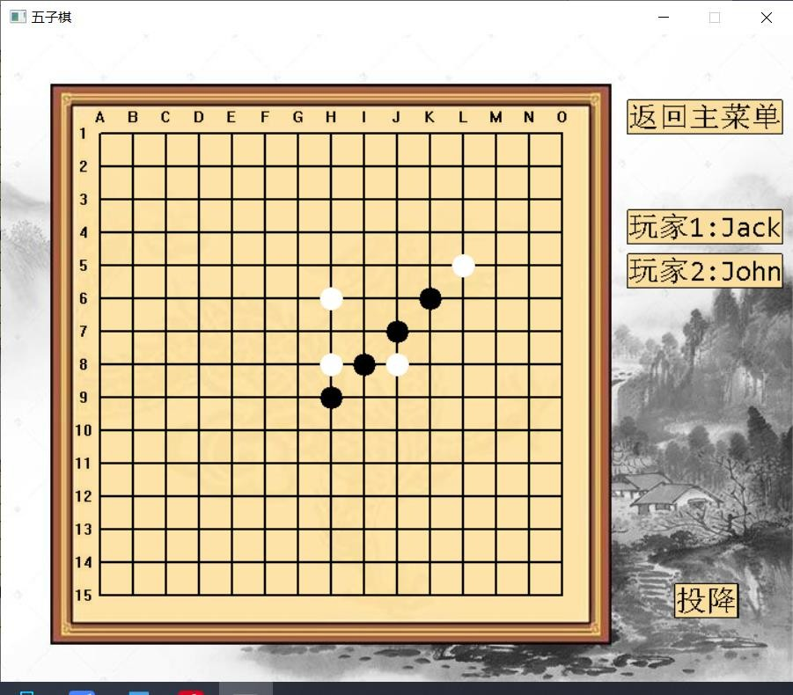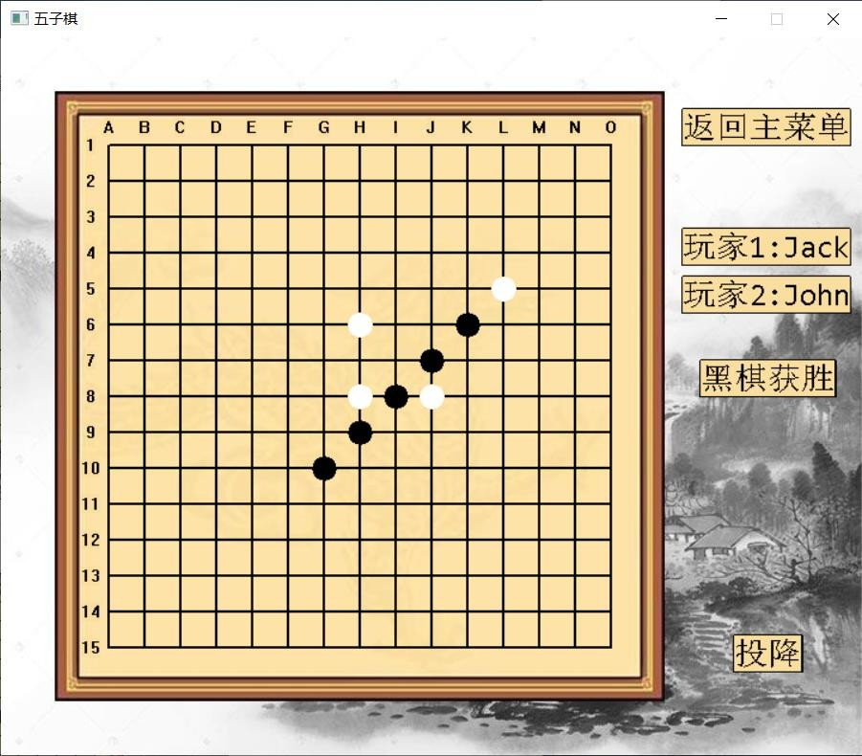

Make unbroken row of four stones bottom-left to top-right diagonally

Unbroken five stones diagonally. Show “黑棋获胜”.

4.2.2.4 Judge_Test_004

|  |  |  |  |
| --- | --- | --- | --- |
| **Test Scenario ID** | Winning_Judge | **Test Case ID** | Judge_004 |
| **Test Case Description** | Verify whether system can identify an unbroken row of five stones top-left to bottom-right diagonally(左上到右下). And finish the game. | **Test Priority** | High |
| **Pre-Requisite** | Start a new game. | **Post Requisite** | Come back to main menu page. Don’t save game. |

|  |  |  |  |  |  |  |
| --- | --- | --- | --- | --- | --- | --- |
| Test Execution Steps | | | | | | |
| **S.NO** | **Action** | **Inputs** | **Expected Output** | **Actual Output** | **Test result** | **Test Comments** |
| 1 | Start new game. | Jack John | Start new game successful. | Start new game successful. | Pass | [Beijing 06/08/2022 15:00 AM]:  Launch successful |
| 2 | Place pieces that make unbroken row of four stones diagonally | Click crosses on the chessboard to place pieces | Pieces can be placed on the chessboard. | Pieces can be placed on the chessboard. | Pass | [Beijing 06/08/2022 15:05 AM]:  Placed successful |
| 3 | Place the last piece that make unbroken row of five stones top- left to bottom-right diagonally | Click cross on the chessboard to place the piece | There are unbroken five stones diagonally. System show “黑棋 获 胜 ”. And show a dialog ask whether to save game. | There are unbroken five stones diagonally. System show “黑棋 获 胜 ” and show the dialog. | Pass | [Beijing 06/08/2022 15:10 AM]:  Winning judgment successful |

Start new game

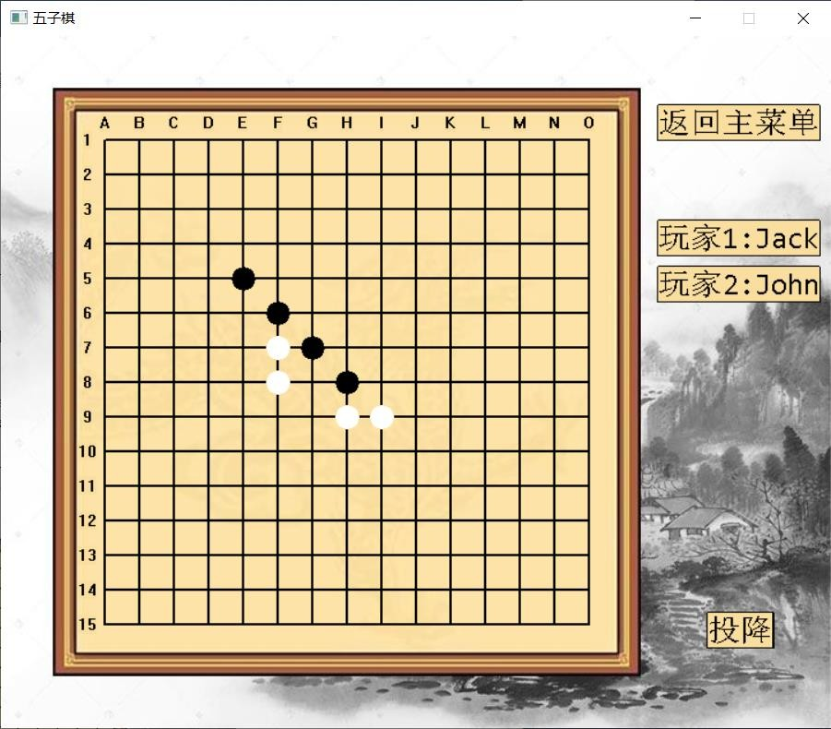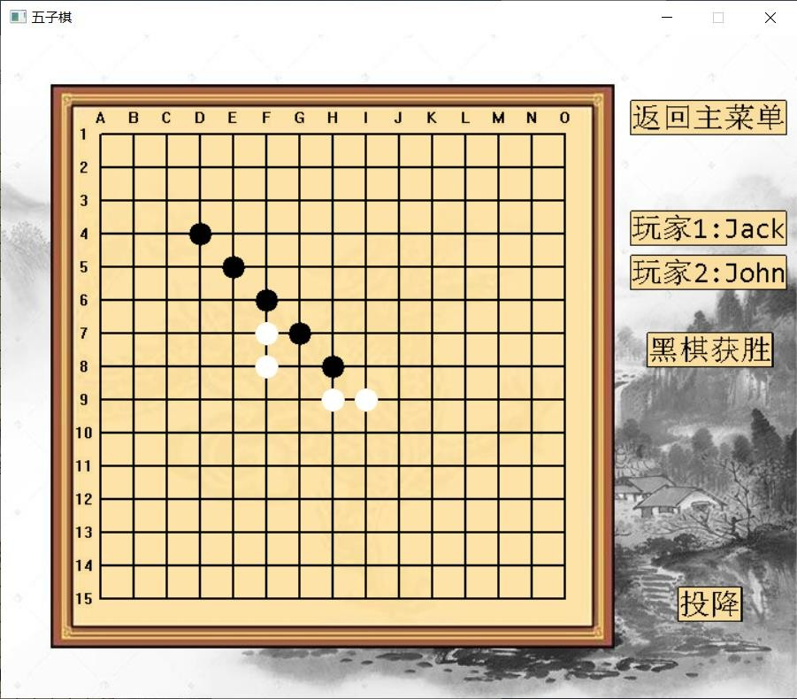

Make unbroken row of four stones top-left to bottom-right diagonally

Unbroken five stones diagonally. Show “黑棋获胜”.

4.2.2.5 Judge_Test_005

|  |  |  |  |
| --- | --- | --- | --- |
| **Test Scenario ID** | Winning_Judge | **Test Case ID** | Judge_005 |
| **Test Case Description** | Verify whether system can identify an unbroken row of five stones near the boundary. | **Test Priority** | High |
| **Pre-Requisite** | Start a new game. | **Post Requisite** | Come back to main menu page. Don’t save game. |

|  |  |  |  |  |  |  |
| --- | --- | --- | --- | --- | --- | --- |
| Test Execution Steps | | | | | | |
| **S.NO** | **Action** | **Inputs** | **Expected Output** | **Actual Output** | **Test result** | **Test Comments** |
| 1 | Start new game. | Jack John | Start new game successful. | Start new game successful. | Pass | [Beijing 06/08/2022 15:20 AM]:  Launch successful |
| 2 | Place pieces that make unbroken row of four stones near the corner of  boundary. | Click crosses on the chessboard to place pieces | Pieces can be placed on the chessboard. | Pieces can be placed on the chessboard. | Pass | [Beijing 06/08/2022 15:25 AM]:  Placed successful |
| 3 | Place the last piece that make unbroken five stones in the boundary. | Click cross on the chessboard to place the piece | There are unbroken five stones in a line. System show “黑棋获胜”. And show a dialog ask whether to save  game. | There are unbroken five stones in a line. System show “黑棋 获 胜 ” and show the dialog. | Pass | [Beijing 06/08/2022 15:30 AM]:  Winning judgment in boundary successful |

Start new game

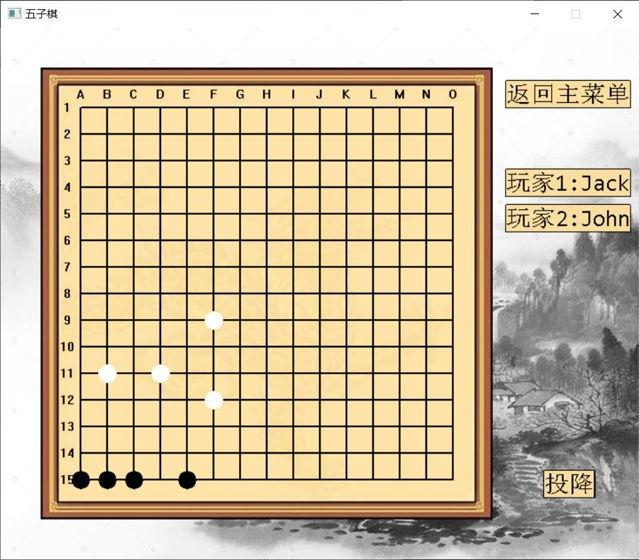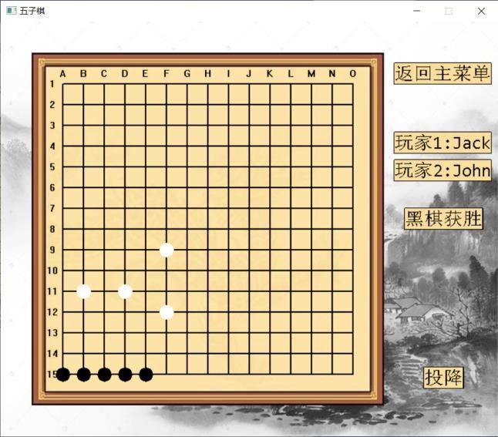

Make unbroken row of four stones near the boundary

Unbroken five stones near the boundary. Show “黑棋获胜”.

* + 1. **game storage & reloading of unfinished game**
       1. SR_Unfinished_001

|  |  |  |  |
| --- | --- | --- | --- |
| **Test Scenario ID** | Store_Reload_Unfinished | **Test Case ID** | SR_Unfinished_001 |
| **Test Case Description** | Verify whether system can shore the unfinished game, and reload the game after. In the correct process. | **Test Priority** | High |
| **Pre-Requisite** | Start a new game. | **Post Requisite** | Come back to main menu page. |
| Test Execution Steps | | | |

|  |  |  |  |  |  |  |
| --- | --- | --- | --- | --- | --- | --- |
| **S.NO** | **Action** | **Inputs** | **Expected Output** | **Actual Output** | **Test result** | **Test Comments** |
| 1 | Start new game. | Jack John | Start new game successful. | Start new game successful. | Pass | [Beijing 06/08/2022 15:40 AM]:  Launch successful |
| 2 | Place some pieces on the chessboard. | Click crosses on the chessboard to place pieces | Pieces can be placed on the chessboard. And game is not over. | Pieces can be placed on the chessboard. And game is not over. | Pass | [Beijing 06/08/2022 15:45 AM]:  Placed successful |
| 3 | Click “返回主菜单” button, and choose “是” | Null | System show dialog that“是否想保存成绩”.  After choose  “是”, show main menu page. | System show dialog that“是否想保存成绩”.  After choose  “是”, show main menu page. | Pass | [Beijing 06/08/2022 15:50 AM]:  Save/Store successful |
| 4 | Click “双人对 战 ” button, and choose “是” | Null | System show dialog that“是否想继续上局游 戏”. After  choose “ 是 ”, show game page, and chessboard the same as the  last game. | Show game page, and chessboard the same as the last the game. | Pass | [Beijing 06/08/2022 15:55 AM]:  Reload successful |

Start new game

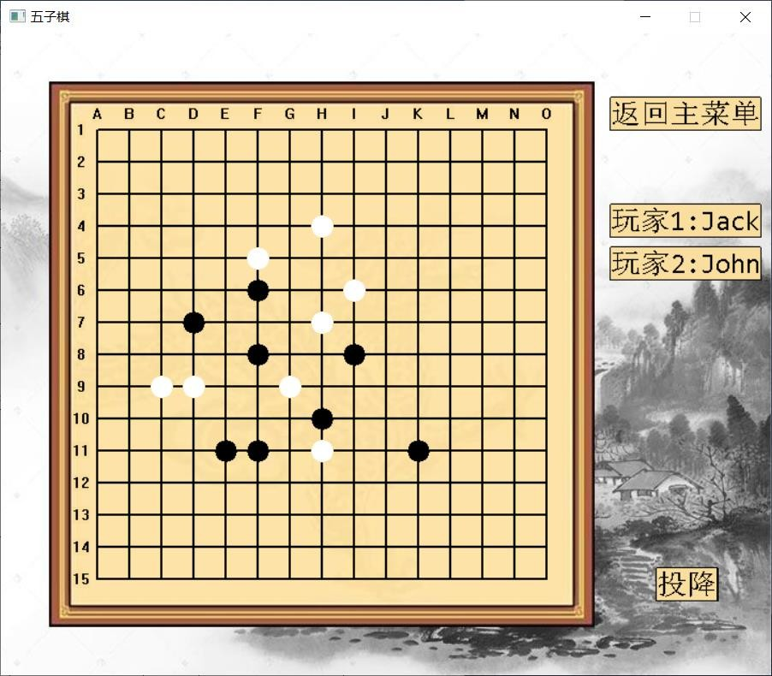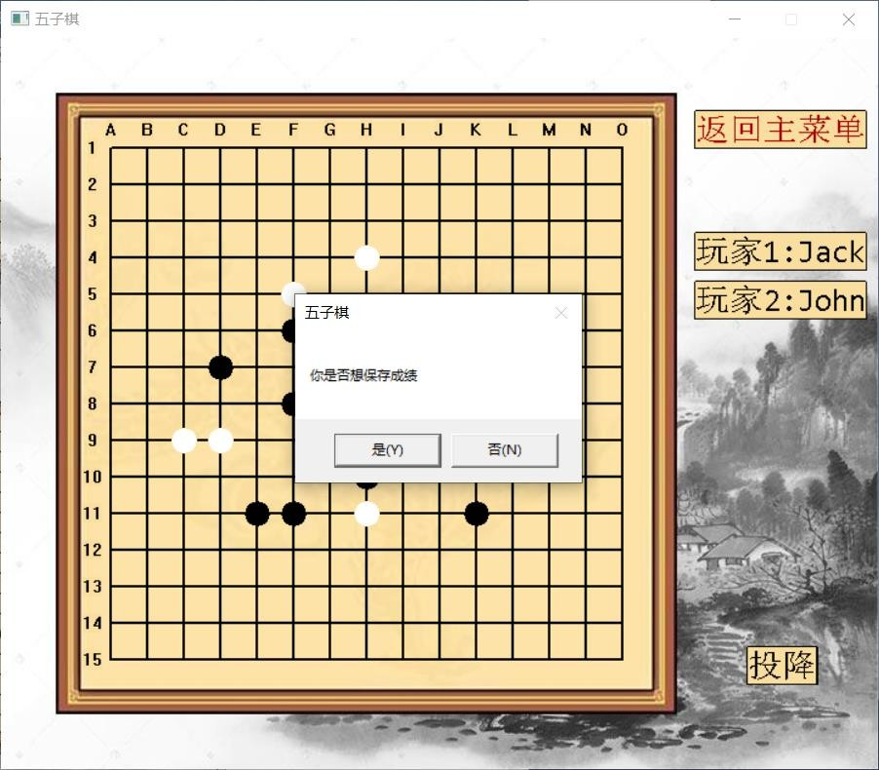

Place some pieces

Click “返回主菜单” button, and choose “是”

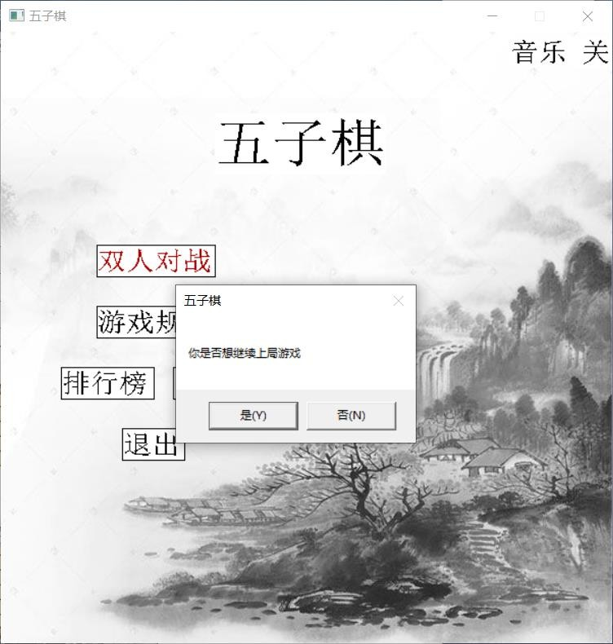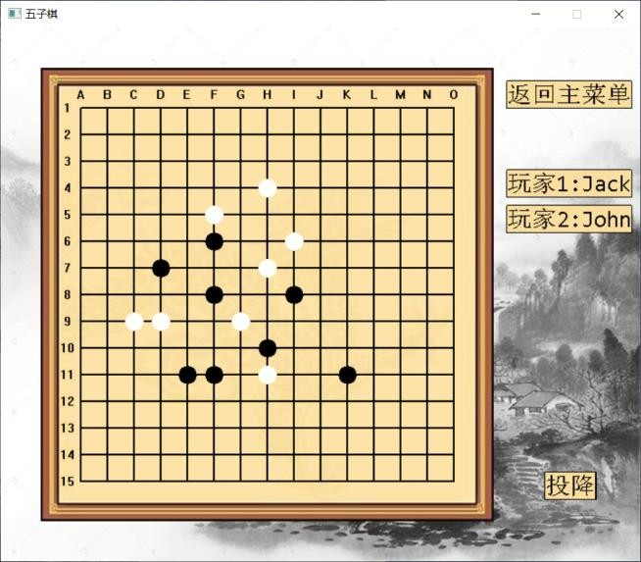

Click “双人对战” button, and choose “是”

Show game page, and chessboard the same as the last the game.

4.2.3.2 SR_Unfinished_002

|  |  |  |  |
| --- | --- | --- | --- |
| **Test Scenario ID** | Store_Reload_Unfinished | **Test Case ID** | SR_Unfinished_002 |
| **Test Case Description** | Verify whether system can shore the unfinished game, and reload the game after. Cancel reloading when start new game. | **Test Priority** | High |
| **Pre-Requisite** | Start a new game. | **Post Requisite** | Come back to main menu page. |

|  |  |  |  |  |  |  |
| --- | --- | --- | --- | --- | --- | --- |
| Test Execution Steps | | | | | | |
| **S.NO** | **Action** | **Inputs** | **Expected Output** | **Actual Output** | **Test result** | **Test Comments** |
| 1 | Start new game. | Jack John | Start new game successful. | Start new game successful. | Pass | [Beijing 06/08/2022 16:00 AM]:  Launch successful |
| 2 | Place some pieces on the chessboard. | Click crosses on the chessboard to place pieces | Pieces can be placed on the chessboard. And game is not over. | Pieces can be placed on the chessboard. And game is not over. | Pass | [Beijing 06/08/2022 16:05 AM]:  Placed successful |
| 3 | Click “返回主菜单” | Null | System show dialog that“是否 | System show dialog that“是否 | Pass | [Beijing 06/08/2022 16:10 AM]: |
|  | button, and choose “是” |  | 想保存成绩”.  After choose | 想保存成绩”.  After choose |  | Save successful |
|  |  |  | “是”, show main | “是”, show main |  |  |
|  |  |  | menu page. | menu page. |  |  |
| 4 | Click “双人 | Null | System show dialog about continuing last game. Start new game after choose  “否” | Start new game | Pass | [Beijing 06/08/2022 16:15 AM]:  Reload is canceled. Storage is removed. |
|  | 对战” |  | after choose “否” |  |
|  | button, and |  |  |  |
|  | choose “否” |  |  |  |

Start new game

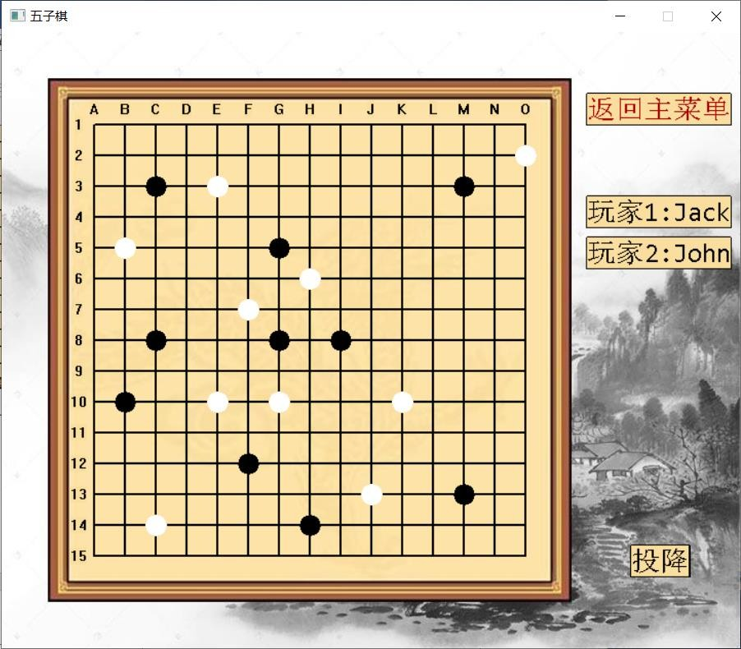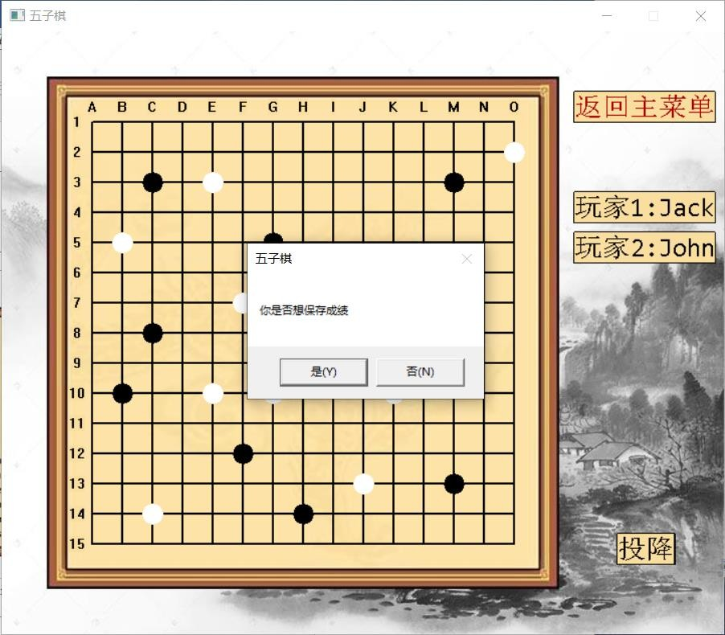

Place some pieces

Click “返回主菜单” button, and choose “是”

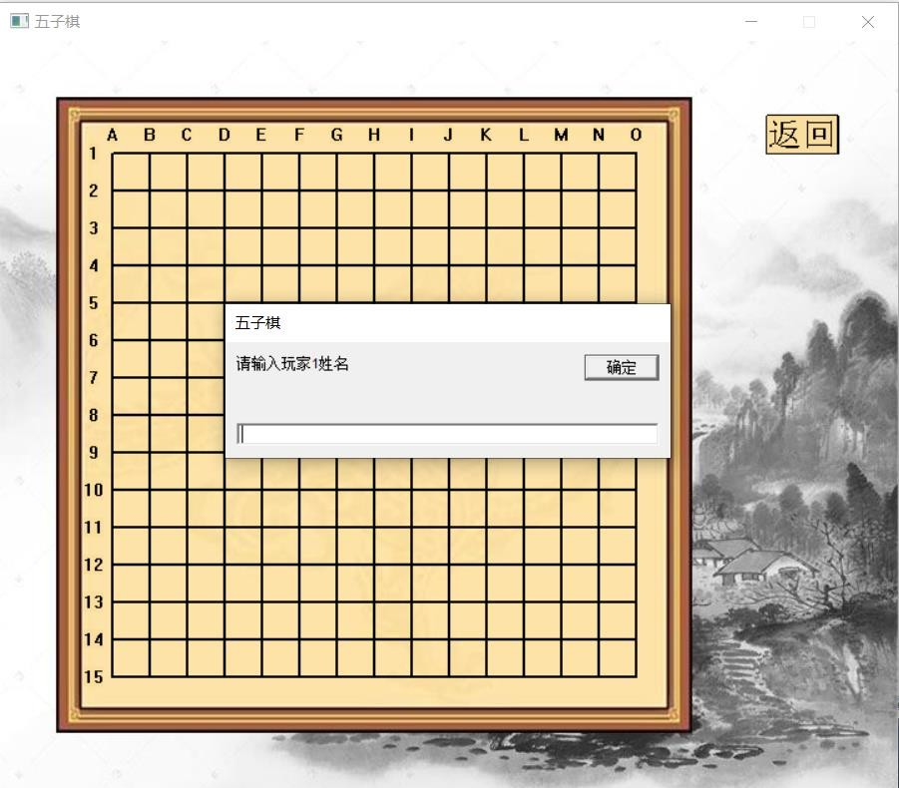

Click “双人对战” button, and choose “否”

Start new game after choose “否”

4.2.3.3 SR_Unfinished_003

|  |  |  |  |
| --- | --- | --- | --- |
| **Test Scenario ID** | Store_Reload_Unfinished | **Test Case ID** | SR_Unfinished_003 |
| **Test Case Description** | Verify whether system can shore the unfinished game, and reload the game after. Cancel storing when ask to save the game. | **Test Priority** | High |
| **Pre-Requisite** | Start a new game. | **Post Requisite** | Come back to main menu |

|  |  |  |  |  |  |  |  |  |  |
| --- | --- | --- | --- | --- | --- | --- | --- | --- | --- |
|  | |  | | | |  | | page. | |
| Test Execution Steps | | | | | | | | | |
| **S.NO** | **Action** | | **Inputs** | **Expected Output** | **Actual Output** | | **Test result** | | **Test Comments** |
| 1 | Start new game. | | Jack John | Start new game successful. | Start new game successful. | | Pass | | [Beijing 06/08/2022 16:20 AM]:  Launch successful |
| 2 | Place some pieces on the chessboard. | | Click crosses on the chessboard to place pieces | Pieces can be placed on the chessboard. And game is not over. | Pieces can be placed on the chessboard. And game is not over. | | Pass | | [Beijing 06/08/2022 16:25 AM]:  Placed successful |
| 3 | Click “返回主菜单” | | Null | System show dialog that“是否 | System show dialog that“是否 | | Pass | | [Beijing 06/08/2022 16:30 AM]: |
|  | button, and choose “否” | |  | 想保存成绩”.  After choose | 想保存成绩”.  After choose | |  | | Cancel successful |
|  |  | |  | “否”, show main | “否”, show main | |  | |  |
|  |  | |  | menu page. | menu page. | |  | |  |
| 4 | Click “双人对 战 ” button. | | Null | Start new game. Doesn’t show dialog about continuing last game. | Start new game. | | Pass | | [Beijing 06/08/2022 16:35 AM]:  Storage is canceled successful |

Start new game

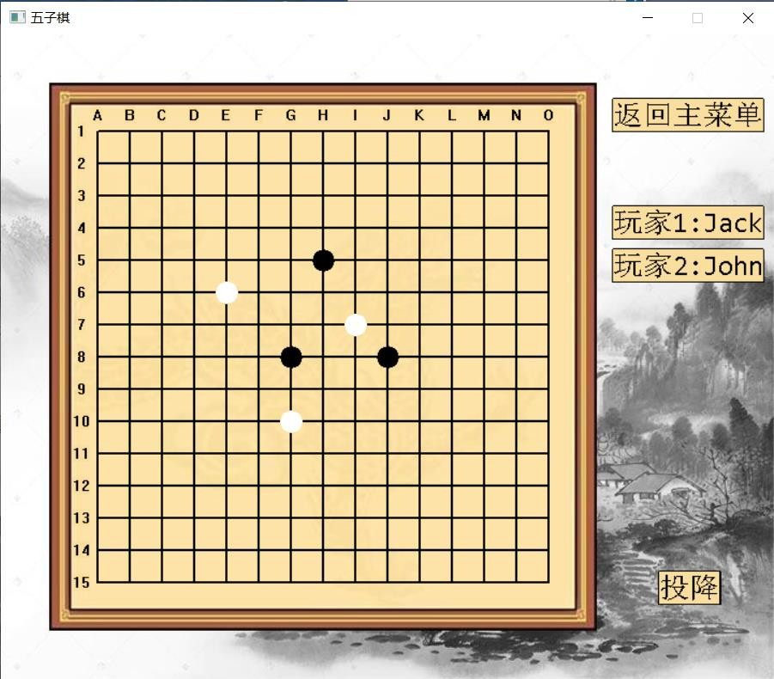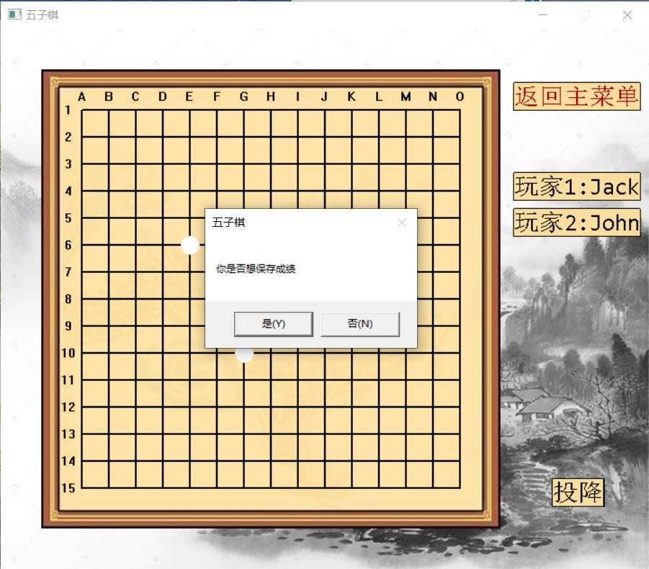

Place some pieces

Click “返回主菜单” button, and choose “否”

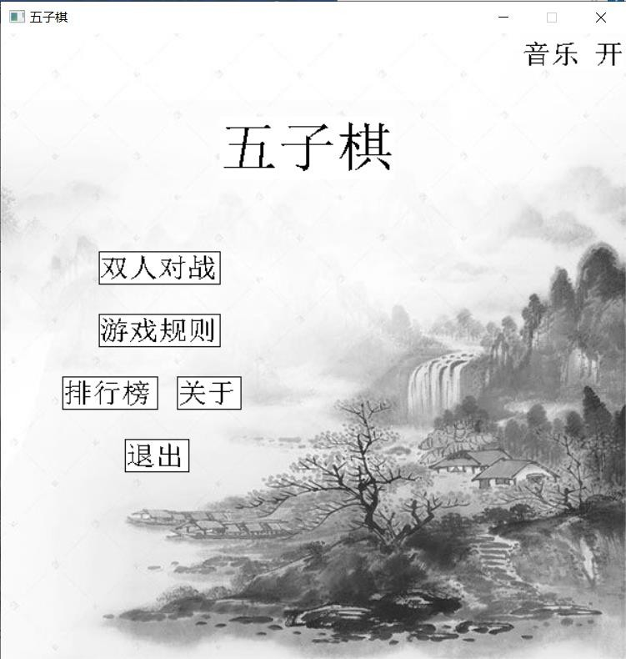

Click “双人对战” button, show new game page.

* + 1. **game storage & playback of finished game**
       1. SR_finished_001

|  |  |  |  |  |  |  |  |  |  |
| --- | --- | --- | --- | --- | --- | --- | --- | --- | --- |
| **Test Scenario ID** | | Store_Reload_Finished | | | | **Test Case ID** | | SR_finished_001 | |
| **Test Case Description** | | Verify whether system can shore the finished game, and reload the game after. In the correct process. | | | | **Test Priority** | | High | |
| **Pre-Requisite** | | Start a new game. | | | | **Post Requisite** | | Come back to main menu page. | |
| Test Execution Steps | | | | | | | | | |
| **S.NO** | **Action** | | **Inputs** | **Expected Output** | **Actual Output** | | **Test result** | | **Test Comments** |
| 1 | Start new game. | | Jack John | Start new game successful. | Start new game successful. | | Pass | | [Beijing 06/08/2022 17:00 AM]:  Launch successful |
| 2 | Place some pieces on the chessboard to make unbroken row of five stones in a line. | | Click crosses on the chessboard to place pieces | Pieces can be placed on the chessboard. And game is over, show “黑棋获胜 ”, and ask whether save the game to ranking  list. | Game is over. Show a dialog that asking whether save the game to ranking list. | | Pass | | [Beijing 06/08/2022 17:05 AM]:  Game over successful |
| 3 | Click “是” | | Null | Show main menu page. | Show main menu page. | | Pass | | [Beijing 06/08/2022 17:10 AM]:  Save/Store successful |

|  |  |  |  |  |  |  |
| --- | --- | --- | --- | --- | --- | --- |
| 4 | Click “排行榜” button. | Null | Show ranking list page. The information of the game is on the list. | Show ranking list page. The information of the game is on the list. | Pass | [Beijing 06/08/2022 17:15 AM]:  Information displayed successful |
| 5 | Click the information of the game.(点击排行榜上的  该局游戏) | Null | Show game page, and the system will show the playback of the game.(显示这一  局游戏的回放) | Show game page, and the system will show the playback of the game. | Pass | [Beijing 06/08/2022 17:20 AM]:  Reload/playback successful |



Start new game

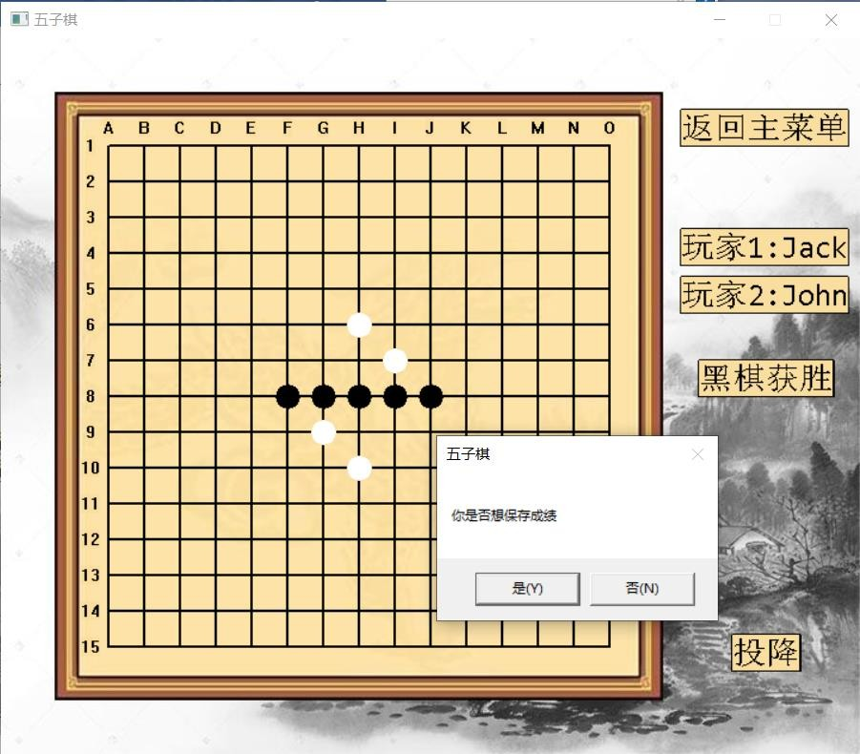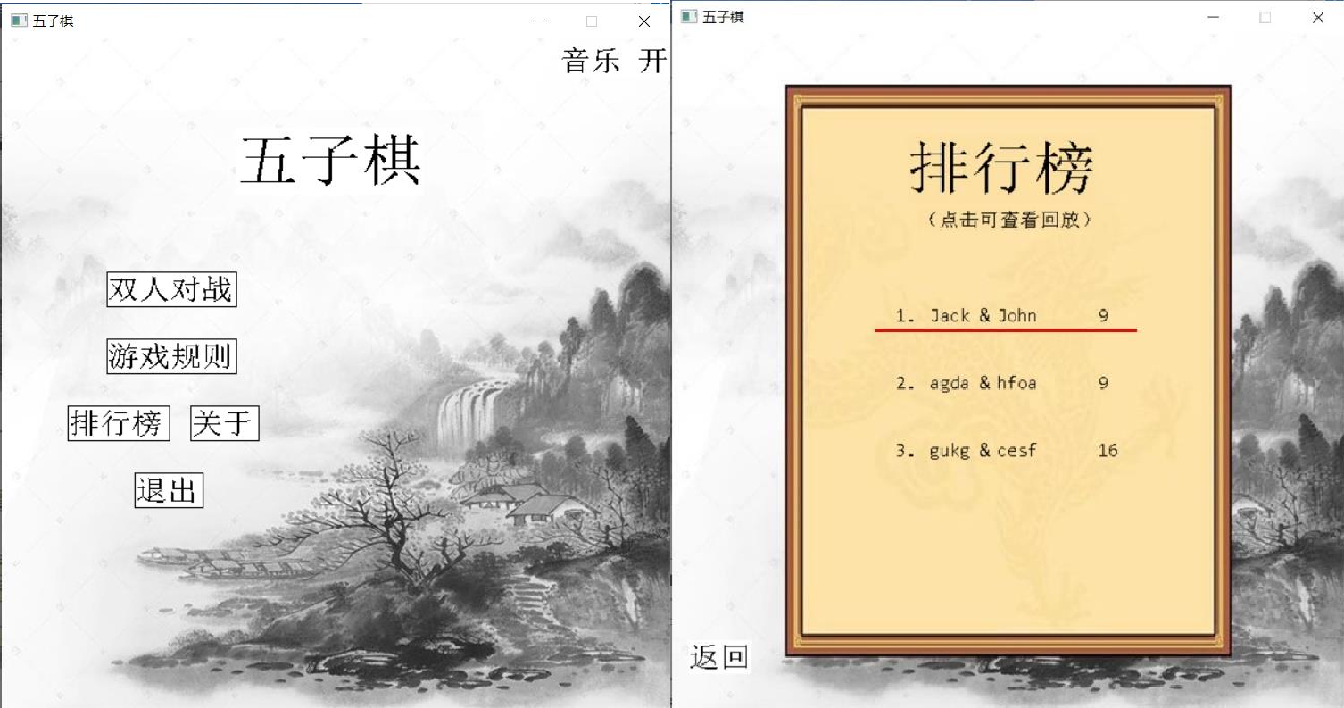

Finish the game, choose “Yes”

Back to main menu, turn to ranking list page.

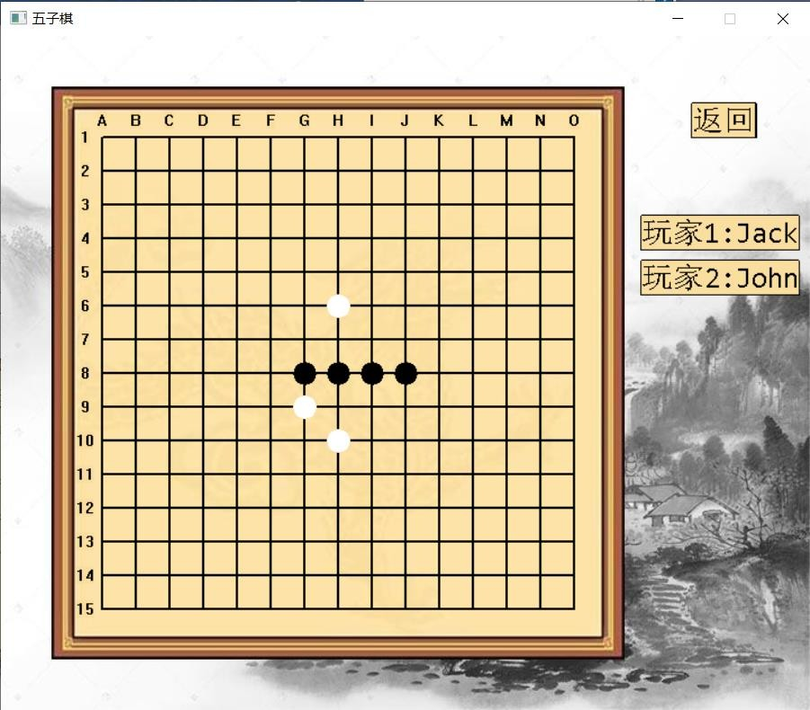

Click “Jack & John”item, show playback

4.2.4.2 SR_finished_002

|  |  |  |  |  |  |  |  |  |  |
| --- | --- | --- | --- | --- | --- | --- | --- | --- | --- |
| **Test Scenario ID** | | Store_Reload_Finished | | | | **Test Case ID** | | SR_finished_002 | |
| **Test Case Description** | | Verify whether system can shore the finished game, and reload the game after. Cancel storing when ask to save the game. | | | | **Test Priority** | | High | |
| **Pre-Requisite** | | Start a new game.（删除数据文件中 John  和 Jack 的上一局比赛信息） | | | | **Post Requisite** | | Come back to main menu page. | |
| Test Execution Steps | | | | | | | | | |
| **S.NO** | **Action** | | **Inputs** | **Expected Output** | **Actual Output** | | **Test result** | | **Test Comments** |
| 1 | Start new game. | | Jack John | Start new game successful. | Start new game successful. | | Pass | | [Beijing 06/08/2022 17:00 AM]:  Launch successful |
| 2 | Place some pieces on the chessboard to make unbroken row of five stones in a line. | | Click crosses on the chessboard to place pieces | Pieces can be placed on the chessboard. And game is over, show “黑棋获胜 ”, and ask whether save the game to ranking  list. | Game is over. Show a dialog that asking whether save the game to ranking list. | | Pass | | [Beijing 06/08/2022 17:05 AM]:  Game over successful |
| 3 | Click “否” | | Null | Show main menu page. | Show main menu page. | | Pass | | [Beijing 06/08/2022 17:10 AM]:  Launch successful |

|  |  |  |  |  |  |  |
| --- | --- | --- | --- | --- | --- | --- |
| 4 | Click “排行榜” button. | Null | Show ranking list page. The information of the game is not showing on the list. | Show ranking list page. The information of the game is not showing on the list. | Pass | [Beijing 06/08/2022 17:15 AM]:  Storage is canceled successful. The game is not saved in the system. |

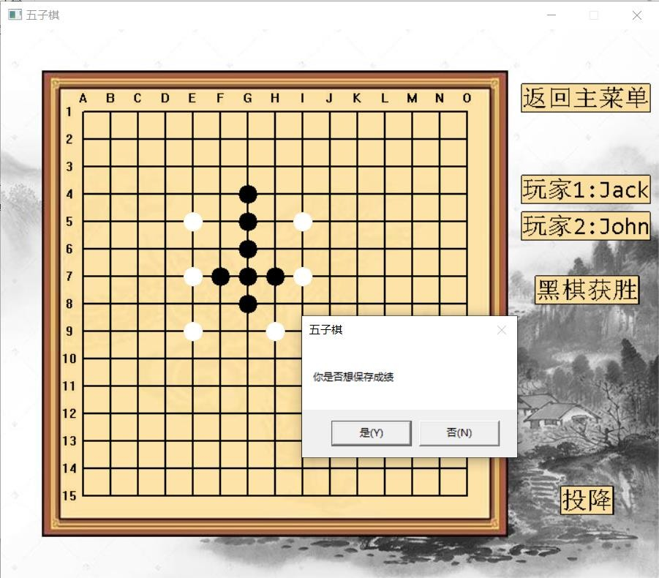

Start new game

Finish the game, choose “No”

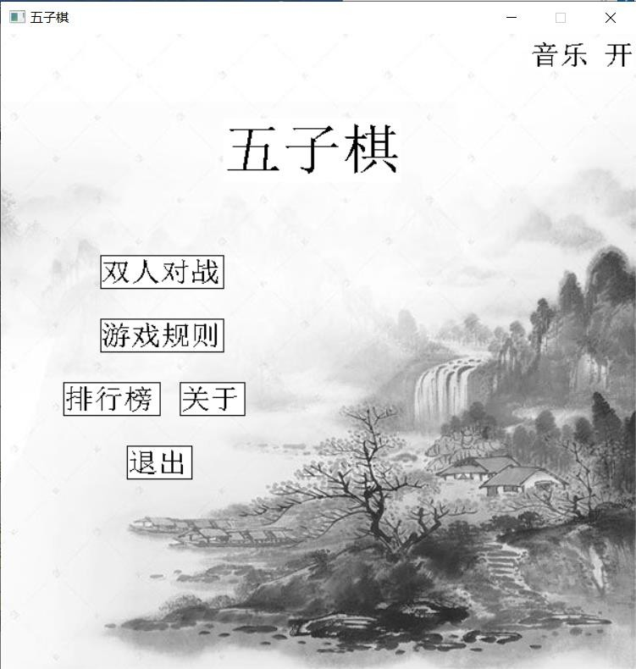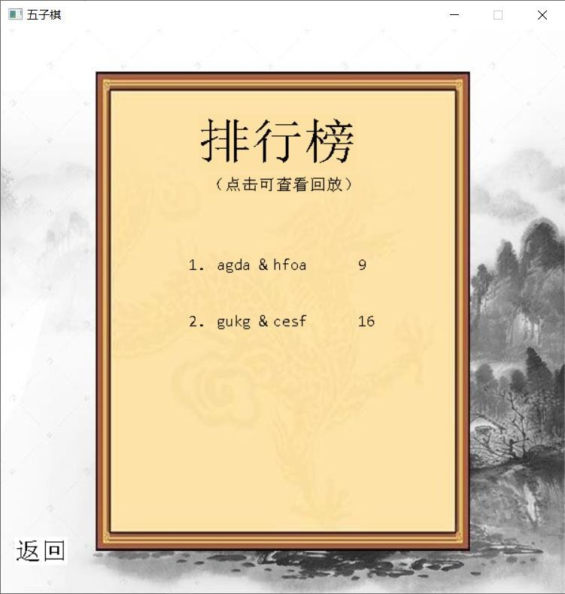

Back to main menu, turn to ranking list page.

There is not the information about “Jack & John”

1. **Defect Reporting**
   1. **Defect Tracking**

Gitee will be used for defect/Issue tracking.

* 1. **Defect Reporting and Reports**

Defects will be reported until 17:00 daily. Defect reports will be generated by gitee defect management tools to be reviewed and analyzed during the daily bugs defects meeting. The reports will be saved on the network and can be found by accessing the below link:

<https://gitee.com/CentanYane/Renju-Game-System/tree/master/>

* 1. **Defect Management Process**

### Create questions

In the test management system, all users can create new problems, including requirements problems and software defects. When creating a problem, you need to describe it clearly and choose the correct option.

### Confirm the problem

Usually, after receiving a new problem, the development engineer needs to analyze and confirm whether the problem is a bug. If it is a bug, select "confirm status"; If it is not considered a bug, indicate the reason and assign it back to the creator.

### Problem solving

This is the main responsibility of the development engineer, including bug recurrence, modification and modification verification.

If the development engineer needs to analyze and solve the confirmed bug in time and verify it by himself, it will be regarded as the solution state.Select the corresponding option for the solution in the defect management system. After the solution is solved, the system will automatically assign it back to the creator.

If the bug cannot be solved or the modification has a great impact, you can apply to enter the "delay solution" process.

### Closing questions

If the bug passes the verification, the verifier needs to indicate the verification result and close it, and the system will assign it to closed.

If a closed bug occurs in a later version, activate the bug and the system will automatically assign it back to the resolver.

* 1. **Defect Severity Definitions**

|  |  |
| --- | --- |
| **Critical** | The defect causes a catastrophic or severe error that results in major problems and the functionality rendered is unavailable to the user. A manual procedure cannot be either implemented or a high effort is required to remedy the defect. Examples of a critical defect are as follows:   * System abends * Data cannot flow through a business function/lifecycle * Data is corrupted or cannot post to the database |

|  |  |
| --- | --- |
| **Medium** | The defect does not seriously impair system function can be categorized as a medium Defect. A manual procedure requiring medium effort can be implemented to remedy the defect. Examples of a medium defect are as follows:   * Form navigation is incorrect * Field labels are not consistent with global terminology |
| **Low** | The defect is cosmetic or has little to no impact on system functionality. A manual procedure requiring low effort can be implemented to remedy the defect. Examples of a low defect are as follows:   * Repositioning of fields on screens * Text font on reports is incorrect |



1. **Environment**

The System Testing Environment will be used for System Testing

* 1. **Hardware Environment**

|  |  |  |
| --- | --- | --- |
| **Hardware Environment** | | |
| test equipment  测试设备 | CPU | 8 核 1.80GHZ |
| Memory | 8G |
| Hard Disk | 1T |

* 1. **Software Environment**

|  |  |  |
| --- | --- | --- |
| **Software Environment** | | |
| test equipment  测试设备 | OS | Windows 10 |
| System type | 64 bit |
| Database type | File(文件存取，因为  是大一的项目) |
| Test software | Visual studio 2019 |

Because the system is created in freshman year(大一), I didn’t know how to use database and server. The project doesn’t have server and advanced database.

1. **Test Schedule**

System testing is scheduled for a period of x weeks starting 05/29/2020 to 06/10/2020. The test team will complete the execution of all the tests during the first 1 weeks. The defects retesting and regression testing will occur in the last week of System Testing. The run dates for defect retesting period may be changed according to the need to retest and close the defects. The defects retesting will reduce the number of open defects that need to be carried to UAT.

|  |  |  |
| --- | --- | --- |
| **Task** | **Date** | **Time** |
| Make test plan | 05/29/2020 ---- 06/03/2020 | 5 Days |
| Black-box test | 06/04/2020 ---- 06/05/2020 | 1 Day |
| White-box test | 06/05/2020 ---- 06/06/2020 | 2 Day |
| Unit test | 06/07/2020 ---- 06/08/2020 | 2 Day |
| System test | 06/09/2020 ---- 06/10/2020 | 2 Day |

1. **Assumptions**

The following assumptions are critical to the successful implementation of this system test method:

* Process of battle by two players is simulated by one tester.
* The test code is always available to tester, and the developer does not take back the code during the test process.
* No force majeure causes interruption of the test process.
* Test equipment is intact that there will be not something wrong with the computer.

1. **Risks and Contingencies**

In the testing work, the main risks are as follows:

* 1. **Demand risk**

Inaccurate understanding of software requirements leads to errors in test scope, missing part of requirements or executing wrong test methods; In addition, requirement changes lead to test case

changes, and there are errors in synchronization.

* 1. **Test case risk**

The test case design is incomplete, ignoring the boundary conditions and exception handling, and the use case does not fully cover the requirements; Test cases are not fully implemented, and some of them are intentionally or unintentionally omitted;

* 1. **Defect risk**

Some defects occur occasionally, which are difficult to reproduce and easy to be missed;

**10**



* 1. **Code quality risk**

The poor quality of software code leads to many defects, and it is easy to miss the test;

* 1. **Test environment risk**

In some cases, the test environment is not completely consistent with the production environment, resulting in errors in the test results;

* 1. **Test technology risk**

Some projects have technical difficulties, test ability and level lead to slow test progress and project delay;

* 1. **Regression test risk**

Generally, regression testing does not run all test cases, which may lead to incomplete testing;

* 1. **Other unpredictable risks**

Some emergencies and force majeure also constitute risk factors, which are difficult to predict and avoid.

**. Appendices**